Credit Card Spending Analysis:
December 2019 vs. January 2020
Statistical Computing: Final Project Report
David Riego
May 2026

1. Introduction and Background
Many people assume that December, the holiday shopping season, brings higher credit card spending compared to January, when budgets typically tighten after the holidays. This study tests whether that assumption holds in a large credit card transaction dataset.

Our central research question is: Is the average credit card transaction amount in December 2019 significantly different from January 2020?

We set up two competing statements (hypotheses):
- Null hypothesis (H₀): The average transaction amounts are the same in both months (μ_{D} = μ_{J}).
- Alternative hypothesis (H_{a}): The average transaction amounts are different (μ_{D} ≠ μ_{J}).

Here, μ_{D} is the true mean transaction amount for December 2019 and μ_{J} is the true mean for January 2020. We use a two-sided test because we want to detect any difference, whether December is higher or lower than January.

The dataset comes from Kaggle (Choksi, 2020) and contains simulated credit card transaction records. The original file had just over one million rows. After filtering to keep only December 2019 and January 2020 records, and removing fraudulent transactions (identified by an “is_fraud = 1” flag in the raw data), the final dataset contained 192,327 legitimate transactions: 140,468 from December 2019 and 51,859 from January 2020.

2. Data Description and Preparation
The dataset is a simulated credit card transaction record sourced from Kaggle (Choksi, 2020). The raw file contained 1,048,575 rows and 24 columns, including cardholder details, merchant information, transaction amounts, and fraud labels. Dates were stored as Excel serial numbers and had to be converted before filtering.

All preprocessing was done in Python using the pandas library (McKinney, 2010). The steps were:
- Converted Excel serial dates to standard datetime objects.
- Filtered rows to keep only December 2019 and January 2020.
- Removed fraudulent transactions
  - dropped all rows with “is_fraud = 1”; 935 rows, about 0.48% of the filtered data.
- Dropped invalid amounts (zero or negative values; none were found).
- Checked for missing values; none were present.

The cleaned file (credit_card_cleaned.csv) was then loaded into R for all further analysis. The cleaned dataset contains four variables. Table 1 describes each one.

Table 1
Variable Descriptions for the Cleaned Credit Card Transaction Dataset
Variable | Type | Description
transaction_date | Date | Date and time of the transaction
period | Categorical (Factor) | Month group: 'December' (2019) or 'January' (2020)
amt | Numerical (Continuous) | Transaction amount in US dollars (USD)
category | Categorical | Merchant category (e.g. entertainment, gas_transport)

Table 2 shows the number of transactions in each month after cleaning.
Table 2
Number of Transactions per Period After Cleaning
Period | n (transactions) | Percentage (%)
December | 140468 | 73
January | 51859 | 27

December 2019 accounts for 140,468 transactions (73.0%) and January 2020 for 51,859 (27.0%), giving a total of 192,327. December has roughly 2.7 times as many transactions as January. Both groups are very large, so any imbalance in size does not affect the validity of our test.

3. Exploratory Data Analysis (EDA)
Before running any formal tests, we explored the data to understand what it looks like, spot patterns, and check whether our assumptions are reasonable.
Table 3 gives a detailed summary of transaction amounts for each period.
Table 3
Descriptive Statistics of Transaction Amounts (USD) by Period
Statistic | December 2019 | January 2020
n (transactions) | 140468.00 | 51859.00
Mean (USD) | 68.22 | 67.11
Median (USD) | 47.16 | 47.38
Std. Deviation | 175.15 | 122.82
Minimum | 1.00 | 1.00
Maximum | 28948.90 | 6880.74
Q1 (25th pct.) | 9.53 | 9.57
Q3 (75th pct.) | 82.43 | 82.80
IQR | 72.90 | 73.23
Skewness | 70.98 | 15.92

The mean transaction amounts are nearly identical: $68.22 for December and $67.11 for January, a difference of only $1.11. The medians are even closer ($47.16 vs. $47.38), meaning the middle value of each group is essentially the same. Both groups have very high standard deviations ($175.15 for December and $122.82 for January), which tells us that transactions vary a lot. Both distributions are severely right-skewed (most transactions are small, but a few are very large), which is typical for financial data. The higher skewness and maximum values for December (max = $28,948.90 vs. $6,880.74 in January) suggest some unusually large holiday purchases, but these are rare.

Figure 1 presents side-by-side boxplots of the raw transaction amounts for December and January.
Figure 1
Boxplot of Raw Transaction Amounts by Period
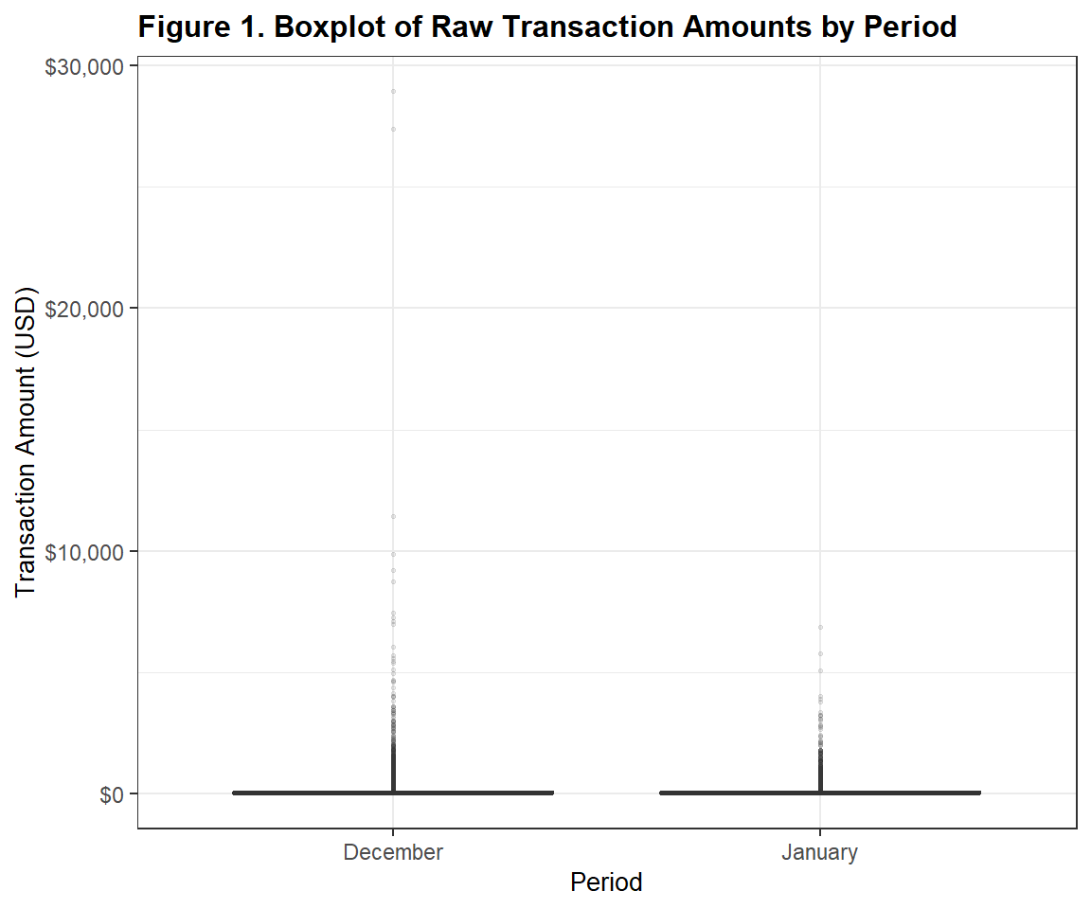

On the raw dollar scale, both boxes are compressed near zero because most transactions are small. The long upper whiskers and scattered dots above them represent the occasional large transactions. The two groups look nearly identical on this scale; any difference in the center is too small to see here.

Figure 2 shows the same boxplots on a log₁₀ scale to better reveal the shape of each distribution.
Figure 2
Boxplot of Log₁₀-Transformed Transaction Amounts by Period
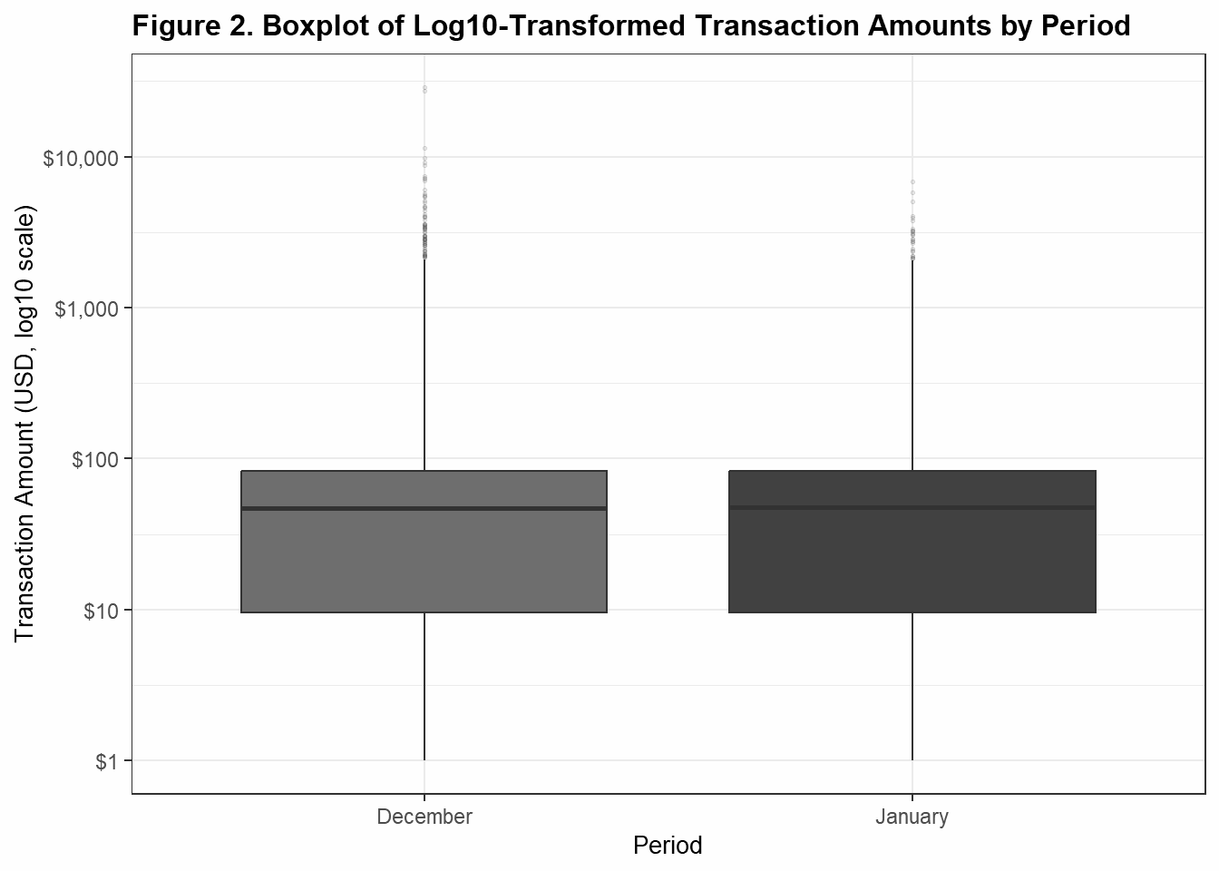

Taking the log₁₀ of transaction amounts spreads out the compressed left side so we can see the distribution more clearly. The median, interquartile range (IQR), and overall spread are nearly identical for December and January. This confirms that the core distributions are very similar.

Figure 3 displays histograms of the raw transaction amounts to show the overall shape of each group.
Figure 3
Histogram of Raw Transaction Amounts by Period
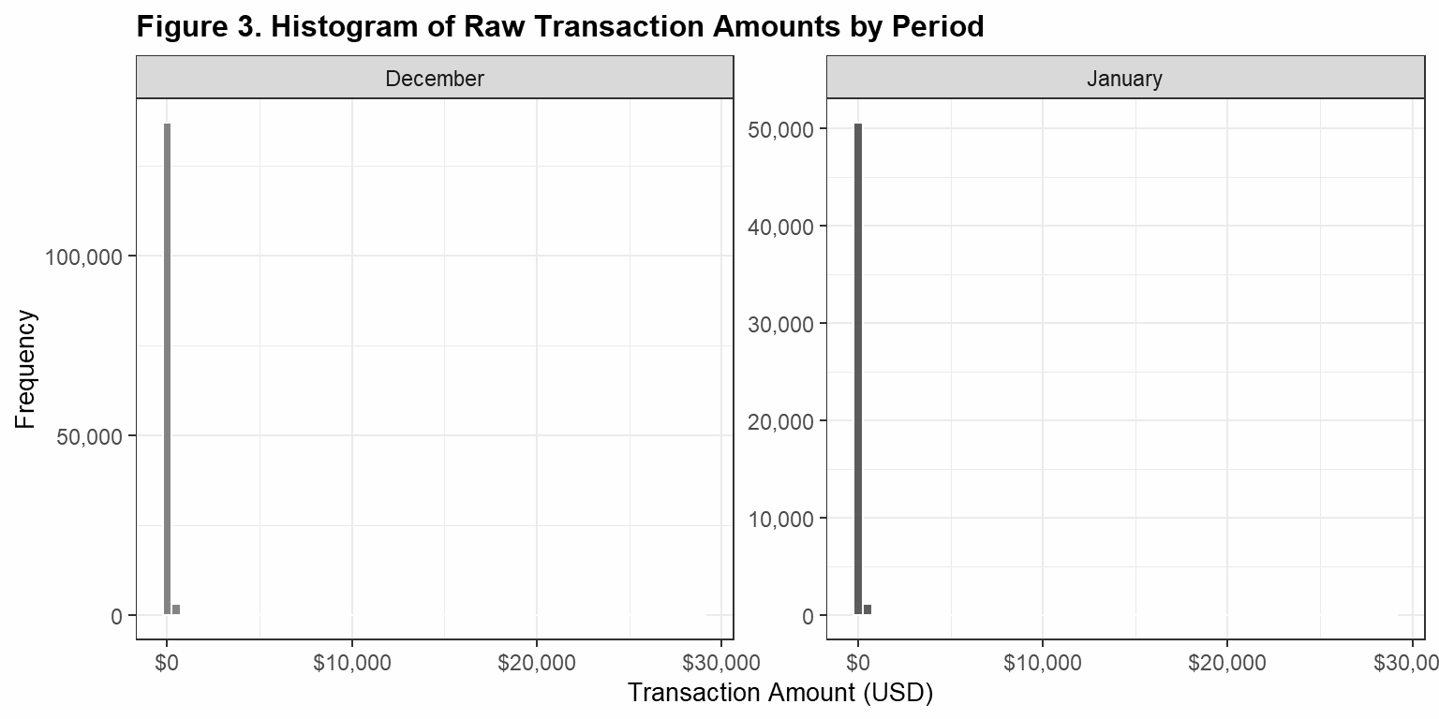

On the raw scale, both histograms show the same pattern: a very tall spike near zero (most transactions are under $200) followed by a long, nearly invisible tail extending to the right. The data is severely right-skewed, and the two groups are almost indistinguishable.

Figure 4 shows the same histograms on the log10 scale, which reveals more detail in the lower range of transaction amounts.
Figure 4
Histogram of Log₁₀-Transformed Transaction Amounts by Period.
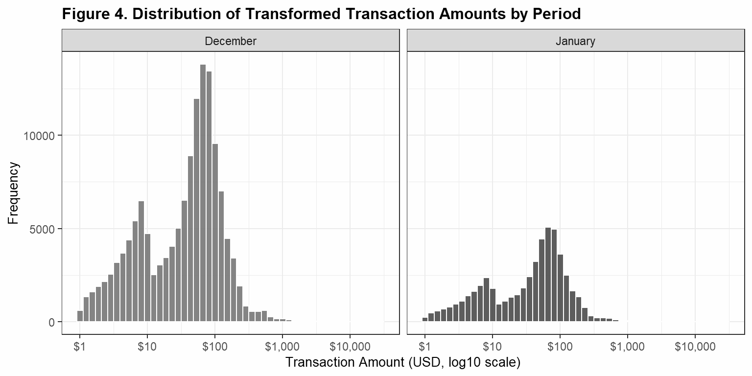
On the log scale, the distributions reveal more structure: a bimodal shape with peaks around $10 and $100. This suggests two types of spending behaviour: frequent small purchases (e.g., fast food, fuel) and less frequent medium-to-large ones (e.g., groceries, retail). This pattern appears in both months with no meaningful difference between them.

4. Classical Hypothesis Testing
We formally test H₀: μ_{D} = μ_{J} against H_{a}: μ_{D} ≠ μ_{J}, using a significance level of α = .05. We will declare a result statistically significant only if the probability of observing data this extreme, assuming the null hypothesis is true, is less than 5%.

Normality check. The Welch t-test works best when the data in each group follows a normal distribution. We checked this with the Shapiro–Wilk test, which gives a p-value: if p < .05, the data departs significantly from normality. Because R’s” shapiro.test()” is capped at 5,000 observations, we drew a random sample of 5,000 transactions from each group and ran the test on each separately.
The R code used is shown below, followed by Figure 5, which displays the normal Q–Q plots for both groups.

# Shapiro-Wilk requires n <= 5000; we draw an independent random sample

# from EACH group and test each group separately.

set.seed(42)

dec_sample <- sample(dec_amt, size = min(5000, length(dec_amt)))

jan_sample <- sample(jan_amt, size = min(5000, length(jan_amt)))

shapiro_dec <- shapiro.test(dec_sample)

shapiro_jan <- shapiro.test(jan_sample)

cat("Shapiro-Wilk Normality Test (per group, n = 5,000 each):\n")

cat(" December: W =", round(shapiro_dec$statistic, 4),

", p-value =", format(shapiro_dec$p.value, scientific = TRUE), "\n")

cat(" January: W =", round(shapiro_jan$statistic, 4),

", p-value =", format(shapiro_jan$p.value, scientific = TRUE), "\n")

Figure 5
Normal Q–Q Plots of Raw Transaction Amounts by Period
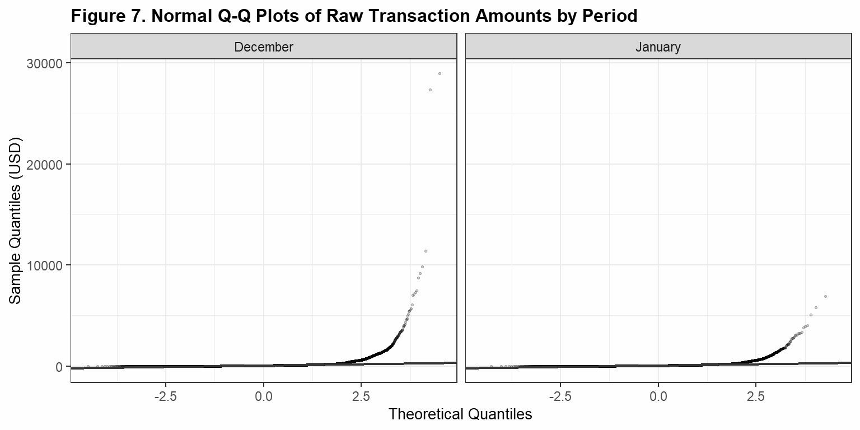
Note. Points that follow the diagonal line indicate normality; heavy departures indicate non-normality.

Both groups had p < .001 (December: W = 0.41; January: W = 0.57). Since these p-values are far below .05, the transaction amounts are not normally distributed in either group. The Q–Q plots confirm this; the points curve sharply away from the diagonal line, especially at the high end. Does this mean we cannot use the t-test? No. The Central Limit Theorem (CLT) tells us that when we take the average of a very large sample, that average will behave like it comes from a normal distribution even if the raw data is not normal. With n_{D} = 140,468 and n_{J} = 51,859, both samples are enormous. The CLT is satisfied, and the Welch t-test is valid.

Equality of variances. We used Levene’s test to check whether the spread (variance) of transaction amounts is similar in both groups.

# Levene's test from the 'car' package

levene_result <- leveneTest(amt ~ period, data = df)

cat("Levene's Test for Equality of Variances:\n")

cat(" F-statistic:", round(levene_result$`F value`[1], 4), "\n")

cat(" p-value: ", format(levene_result$`Pr(>F)`[1], scientific = TRUE), "\n")

Levene’s test gave F(1, 192325) = 2.20, p = .138. Because p = .138 > .05, we do not have evidence that the variances are significantly different. We still use the Welch t-test, which handles unequal variances, for extra robustness.

Test selection. We use the Welch two-sample t-test on the raw transaction amounts. This test is appropriate because our hypothesis is about means, the CLT justifies it despite non-normality, and Welch’s correction handles groups of different sizes and spreads.

# Welch two-sample t-test on RAW transaction amounts (two-tailed).

# CLT (Section 4.2) justifies the parametric inference for n this large.

t_result <- t.test(

x = dec_amt,

y = jan_amt,

alternative = "two.sided",

var.equal = FALSE,

conf.level = 0.95

)

print(t_result)

# Extract each output component into a named variable

t_stat <- round(t_result$statistic, 4)

t_df <- formatC(t_result$parameter, format = "d", big.mark = ",")

t_p_value <- t_result$p.value

t_ci_lower <- round(t_result$conf.int[1], 4)

t_ci_upper <- round(t_result$conf.int[2], 4)

t_mean_dec <- round(t_result$estimate[1], 2)

t_mean_jan <- round(t_result$estimate[2], 2)

t_diff <- round(t_mean_dec - t_mean_jan, 4)

cat("=== Welch Two-Sample t-Test Results ===\n\n")

cat("t-statistic: ", t_stat, "\n")

cat("Degrees of freedom: ", t_df, "\n")

cat("p-value: ", format(t_p_value, scientific = TRUE), "\n")

cat("Mean (December, USD): ", t_mean_dec, "\n")

cat("Mean (January, USD): ", t_mean_jan, "\n")

cat("Difference (Dec - Jan): ", t_diff, "\n")

cat("95% CI for difference: [", t_ci_lower, ",", t_ci_upper, "]\n")

Table 4 presents the complete results of the Welch t-test.
Table 4
Welch Two-Sample t-Test Results for December 2019 vs. January 2020
Measure | Value
Mean transaction amount (December, USD) | 68.22
Mean transaction amount (January, USD) | 67.11
Observed mean difference (USD) | 1.11
t-statistic | 1.5527
Degrees of freedom | 131,580
p-value (two-sided) | .121
95% CI for μ_{D} − μ_{J} (USD) | [−0.29, 2.51]
Note. Welch’s correction applied (var.equal = FALSE). Test conducted on all 192,327 transactions. α = .05.

The t-test gave t(131,580) = 1.5527, p = .121. Since p = .121 is greater than α = .05, we do not reject the null hypothesis. There is no statistically significant difference in mean credit card transaction amounts between December 2019 and January 2020. The 95% confidence interval for the difference (μ_{D} − μ_{J}) is [−$0.29, $2.51], which includes zero, consistent with the p-value conclusion. In plain terms, the observed difference of $1.11 is so small relative to the natural variation in transaction amounts that it could easily be due to random chance alone.

5. Computational Inference
The Welch t-test reached its conclusion using a mathematical formula. The bootstrap reaches a conclusion a completely different way: by using the data itself to figure out how much the result could vary by chance.

Resampling with replacement means we pick transactions randomly from the original sample; any transaction can be picked more than once (or not at all) in a single simulated sample. We do this B = 10,000 times and compute the difference in means each time. The result is a bootstrap distribution: a picture of how the mean difference would vary across many hypothetical reruns of the study.

Transaction amounts are severely right-skewed. While the CLT already makes the t-test valid for our large samples, the bootstrap is an independent check that requires no distributional assumptions at all; it does not need the data to be normal and does not rely on the CLT. If both approaches give the same answer, we can be more confident in the result.

The procedure used: we resample December (n = 140,468) and January (n = 51,859) independently with replacement, preserving original group sizes, and compute the difference in sample means each time, δ̂ = X̄_{Dec} − X̄_{Jan}. We repeat this B = 10,000 times. The 95% percentile confidence interval is the 2.5th to 97.5th percentile of the bootstrap distribution. For the bootstrap p-value, both groups are shifted to the grand mean (forcing H₀ to be true) and then resampled 10,000 times; the p-value is the proportion of those resamples whose absolute mean difference is at least as large as the observed |δ̂| = $1.11.

set.seed(42)

B <- 10000

obs_diff <- mean(dec_amt) - mean(jan_amt)

# Resample each group independently with replacement

boot_diffs <- replicate(B, {

mean(sample(dec_amt, replace = TRUE)) -

mean(sample(jan_amt, replace = TRUE))

})

# 95% percentile confidence interval

boot_ci_lower <- round(quantile(boot_diffs, 0.025), 4)

boot_ci_upper <- round(quantile(boot_diffs, 0.975), 4)

# Bootstrap p-value: recenter both groups under H0 (grand mean)

grand_mean <- mean(c(dec_amt, jan_amt))

dec_c <- dec_amt - mean(dec_amt) + grand_mean

jan_c <- jan_amt - mean(jan_amt) + grand_mean

boot_null_diffs <- replicate(B, {

mean(sample(dec_c, replace = TRUE)) -

mean(sample(jan_c, replace = TRUE))

})

boot_p <- mean(abs(boot_null_diffs) >= abs(obs_diff))

boot_p_fmt <- ifelse(boot_p < .001, "< .001",

paste0("= ", round(boot_p, 3)))

Figure 6 shows the bootstrap distribution of the mean difference across all 10,000 resamples, with the observed difference and 95% confidence interval bounds marked.
Figure 6
Bootstrap Distribution of the Difference in Mean Transaction Amounts (December − January), Based on 10,000 Resamples.
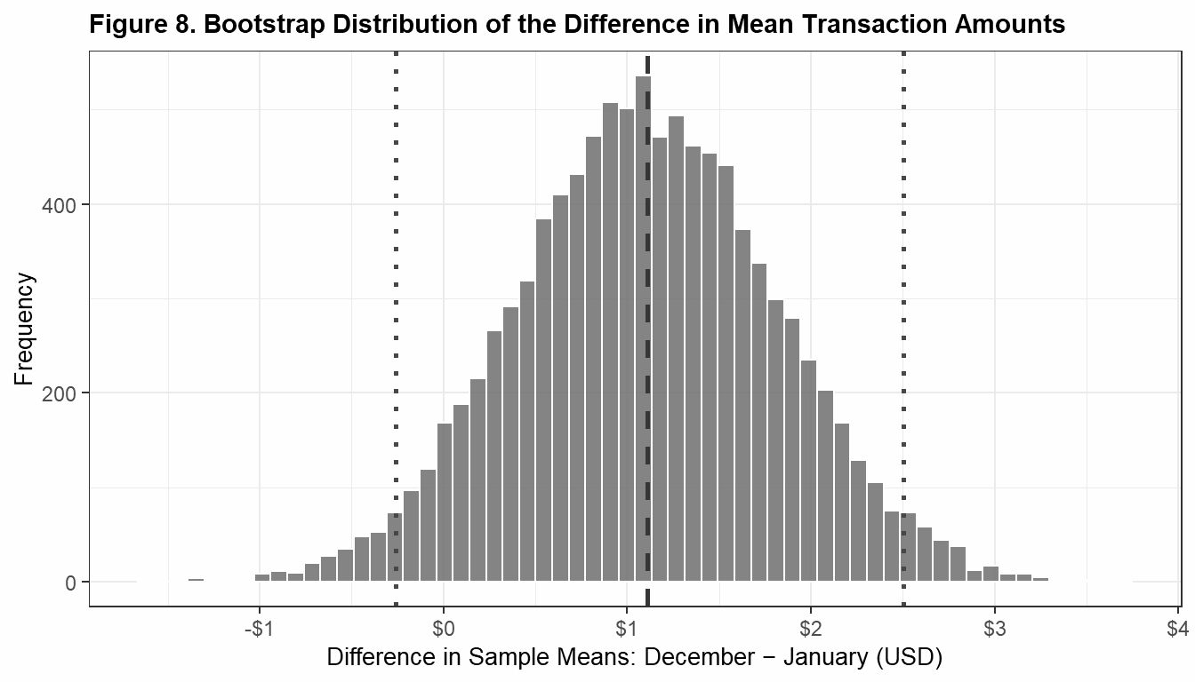
Note: Dashed line = observed mean difference ($1.11). Dotted lines = 95% confidence interval bounds.

Across B = 10,000 resamples, the observed mean difference was $1.108 and the 95% bootstrap confidence interval for μ_{D} − μ_{J} was [−$0.26, $2.50]. The bootstrap p-value was p = .128. Since p = .128 is greater than α = .05, the bootstrap also finds no statistically significant difference in mean transaction amounts between the two months. The bootstrap distribution (Figure 6) is centred just above $1, and both CI bounds are fairly close to zero, with the left bound slightly below it; zero is always a plausible value for the true difference.

6. Discussion and Synthesis
We expected December to show higher average transaction amounts than January, driven by holiday shopping. Our analysis did not support this. The mean amounts were nearly identical: $68.22 in December versus $67.11 in January, a difference of just $1.11. The medians were even closer ($47.16 vs. $47.38), differing by less than $1.

The Welch t-test gave p = .121. Since this is greater than .05, we do not reject the null hypothesis. The bootstrap gave p = .128, leading to the same conclusion. Both methods agree: there is no statistically significant difference in mean transaction amounts between December 2019 and January 2020. The most likely explanation is not a flaw in the analysis but in the data itself: this is a simulated dataset, and the simulation algorithm likely generated transaction amounts from a fixed distribution without encoding any real-world seasonal patterns.

Several patterns from the exploratory analysis are consistent with the null result. The boxplots and histograms (Figures 1 through 4) showed that December and January transaction amounts are nearly identical in terms of their means, medians, and overall spread. On the log scale, both months display the same bimodal shape with peaks around $10 and $100, suggesting two types of consumer behaviour: frequent small purchases and less frequent larger ones. December had more extreme high-value transactions (max = $28,948.90 vs. $6,880.74) and a higher standard deviation ($175.15 vs. $122.82), which may reflect occasional large holiday purchases, but these are a very small fraction of all transactions.

EDA vs. t-test. Before running any formal test, the plots and summary statistics already predicted a null result. The boxplots and histograms showed near-identical distributions; the means, medians, and IQRs were essentially equal. The t-test confirmed this: with p = .121, the observed $1.11 difference is well within what random chance could produce.

t-test vs. bootstrap. The bootstrap gave p = .128, extremely close to the t-test’s p = .121. The 95% CI from the t-test was [−$0.29, $2.51]; the bootstrap CI was very similar at [−$0.26, $2.50]. Both include zero; both produce p-values well above .05. This close agreement is exactly what we expect when samples are large: with n_{D} = 140,468 and n_{J} = 51,859, the CLT ensures that the t-test and the bootstrap converge to the same answer.

Which method is more appropriate? For right-skewed financial data, the bootstrap is technically the safer choice because it makes no assumptions about the shape of the data. The t-test relies on the CLT, which is valid here given the large samples but would not hold for small samples of skewed data. In this specific study, both methods are equally valid. The fact that they agree makes the conclusion more reliable.

7. Recommendations
Limitations and Data Issues.
- Simulated data: the primary limitation. The dataset (Choksi, 2020) was synthetically generated to resemble real credit card transactions, not sourced from actual financial records. The simulation likely generated transaction amounts from a fixed underlying distribution without encoding real-world seasonal patterns. This explains why the distributions are nearly identical across months. In real data, at least some seasonal variation would be expected. Using simulated data does not invalidate the methodology; the analysis was rigorous and correct. However, the dataset is simply not the right tool for detecting a real-world seasonal spending effect.
- Non-normality, mitigated by the CLT. Transaction amounts are extremely right-skewed (Shapiro–Wilk p < .001 in both groups). In a small-sample setting this would invalidate a parametric t-test. Here, the large sample sizes make the CLT applicable, so the test is valid. Readers should be aware that the raw-data normality assumption is not satisfied; the test relies explicitly on the CLT.
- No covariate control. Transaction amounts were compared in aggregate, without controlling for spending category, cardholder demographics, time of day, or merchant type. A stratified or regression-based analysis could reveal sub-group differences even when the aggregate does not.
- Single time-period comparison. This study examines one December–January transition. Even with real data, a single year’s comparison may not represent a stable seasonal pattern. Multi-year data would provide more reliable estimates.

Suggestions for Future Studies.
- Use real transaction data. The most important next step is to replicate this analysis with actual credit card records. Real datasets would capture genuine seasonal variation if it exists. Publicly available real-world datasets with sufficient historical depth can be difficult to source; many contain only a few days of records. Future work should prioritise obtaining institutional datasets with at least one full year of transaction history.
- Extend the time period. Analysing multiple December–January pairs (e.g., 2016–2017 through 2022–2023) would reveal whether any seasonal pattern is consistent across years or isolated to a specific period.
- Stratify by spending category. Even if the overall distribution does not differ, individual categories (e.g., shopping, travel, entertainment) might show seasonal patterns that are masked in the aggregate.
- Control for demographic and economic factors. A regression framework incorporating cardholder demographics and macroeconomic indicators (e.g., consumer confidence, inflation) would allow for a more nuanced understanding of what drives month-to-month spending differences.
- Examine transaction frequency alongside amount. This study focused on transaction amounts. Future work could also examine whether consumers make more transactions in December regardless of the amount per transaction: a different dimension of holiday spending behaviour.
- Assess bootstrap stability. The bootstrap results here used B = 10,000 resamples. Future work could replicate the analysis across a range of B values (e.g., 1,000 to 100,000) to confirm that the confidence interval and p-value estimates are stable and not sensitive to the choice of B.

8. References
Choksi, P. (2020). Credit card transactions fraud detection dataset [Data set]. Kaggle. https://www.kaggle.com/datasets/priyamchoksi/credit-card-transactions-dataset
Efron, B., & Tibshirani, R. J. (1993). An introduction to the bootstrap. Chapman & Hall/CRC. https://doi.org/10.1201/9780429246593
Fox, J., & Weisberg, S. (2019). An R companion to applied regression (3rd ed.). Sage Publications.
Komsta, L., & Novomestky, F. (2022). moments: Moments, cumulants, skewness, kurtosis and related tests [R package version 0.14.1]. https://CRAN.R-project.org/package=moments
McKinney, W. (2010). Data structures for statistical computing in Python. In S. van der Walt & J. Millman (Eds.), Proceedings of the 9th Python in Science Conference (pp. 51–56). https://doi.org/10.25080/Majora-92bf1922-00a
R Core Team. (2024). R: A language and environment for statistical computing [Computer software]. R Foundation for Statistical Computing. https://www.R-project.org/
Wickham, H. (2016). ggplot2: Elegant graphics for data analysis. Springer-Verlag. https://ggplot2.tidyverse.org
Wickham, H., Averick, M., Bryan, J., Chang, W., McGowan, L. D., François, R., Grolemund, G., Hayes, A., Henry, L., Hester, J., Kuhn, M., Pedersen, T. L., Miller, E., Bache, S. M., Müller, K., Ooms, J., Robinson, D., Seidel, D. P., Spinu, V., … Yutani, H. (2019). Welcome to the tidyverse. Journal of Open Source Software, 4(43), 1686. https://doi.org/10.21105/joss.01686
Xie, Y. (2024). knitr: A general-purpose package for dynamic report generation in R [R package]. https://yihui.org/knitr/
Zhu, H. (2024). kableExtra: Construct complex table with ‘kable’ and pipe syntax [R package]. https://CRAN.R-project.org/package=kableExtra

